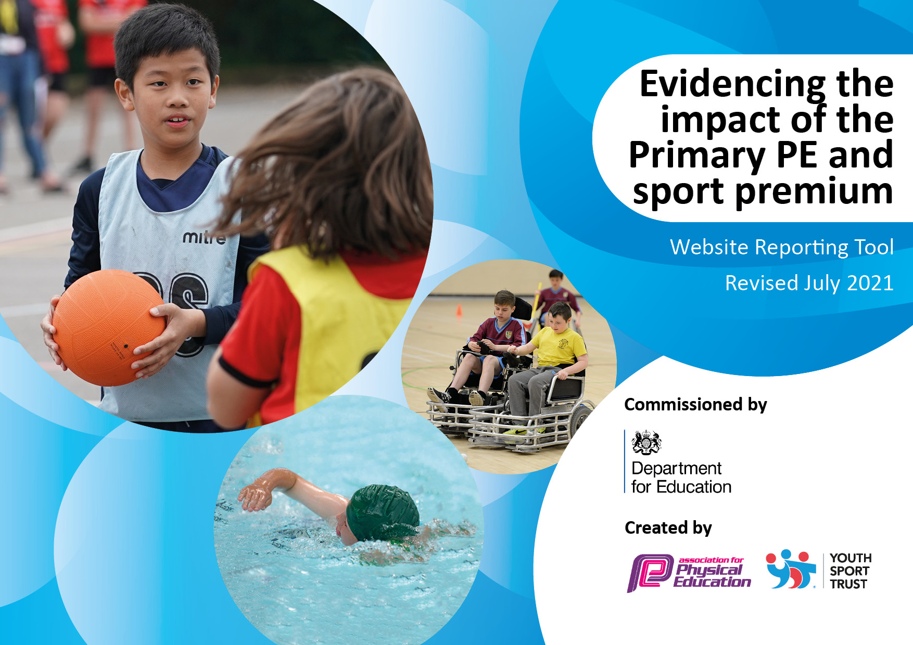
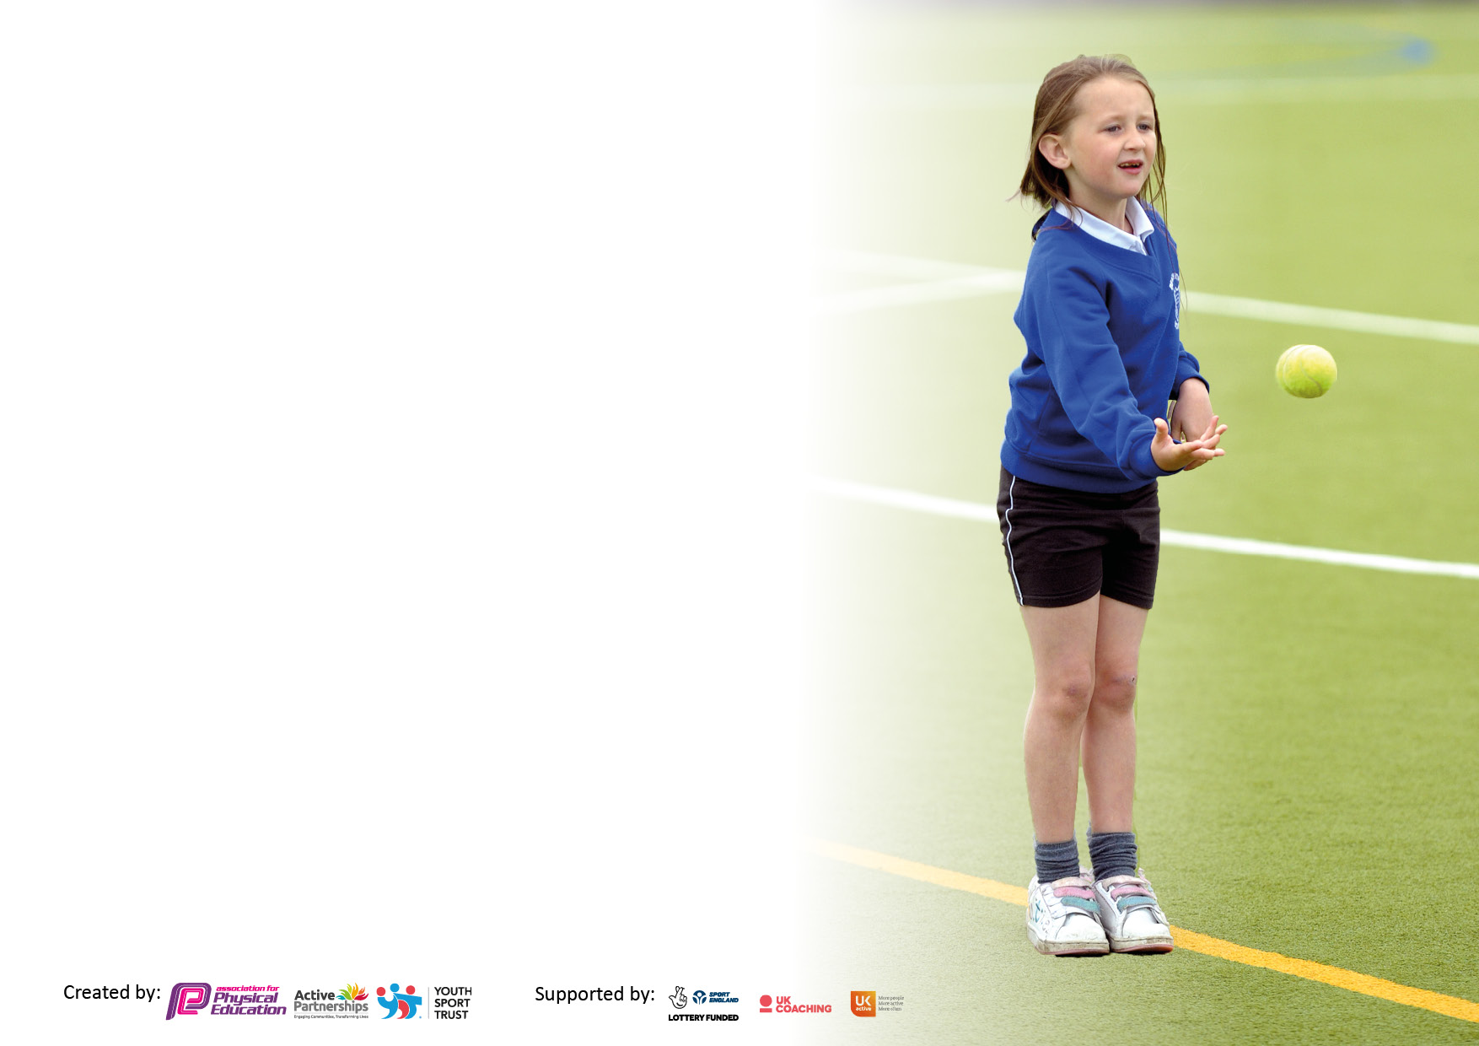

It is important that your grant is used effectively and based on school need. The Education Inspection Framework makes clear there will be a focus on ‘whether leaders and those responsible for governors all understand their respective roles and perform these in a way that enhances the effectiveness of the school’.

Under the Quality of Education Ofsted inspectors consider:
Intent - Curriculum design, coverage and appropriateness
Implementation - Curriculum delivery, Teaching (pedagogy) and Assessment
Impact - Attainment and progress

To assist schools with common transferable language this template has been developed to utilise the same three headings which should make your plans easily transferable between working documents.

Schools must use the funding to make additional and sustainable improvements to the quality of Physical Education, School Sport and Physical Activity (PESSPA) they offer. This means that you should use the Primary PE and sport premium to:

- Develop or add to the PESSPA activities that your school already offer
- Build capacity and capability within the school to ensure that improvements made now will benefit pupils joining the school in future years
- The Primary PE and sport premium should not be used to fund capital spend projects; the school’s budget should fund these.

Pleasevisitgov.ukfortherevisedDfEguidanceincludingthe5keyindicatorsacrosswhichschoolsshoulddemonstrate animprovement.Thisdocumentwillhelpyoutoreviewyourprovisionandtoreportyourspend.DfEencouragesschools to use this template as an effective way of meeting the reporting requirements of the Primary PE and sport premium.

We recommend you start by reflecting on the impact of current provision and reviewing the previous spend.

Schools are required to publish details of how they spend this funding, including any under-spend from 2019/2020, as well as on the impact it has on pupils’ PE and sport participation and attainment. All funding must be spent by 31st July 2022.

We recommend regularly updating the table and publishing it on your website throughout the year. This evidences your ongoing self-evaluation of how you are using the funding to secure maximum, sustainable impact. Final copy must be posted on your website by the end of the academic year and no later than the 31st July 2021. To see an example of how to complete the table please click HERE.
Created by: Supported by:

Details with regard to funding
Please complete the table below.

Total amount carried over from 2019/20 | £ 0
Total amount allocated for 2020/21 | £17,760
How much (if any) do you intend to carry over from this total fund into 2021/22? | £ 0
Total amount allocated for 2021/22 | £17760
Total amount of funding for 2021/22. To be spent and reported on by 31st July 2022. | £18,446
Swimming Data
Please report on your Swimming Data below.

Meeting national curriculum requirements for swimming and water safety.

N.B. Complete this section to your best ability. For example you might have practised safe self-rescue techniques on dry land which you can then transfer to the pool when school swimming restarts.
Due to exceptional circumstances priority should be given to ensuring that pupils can perform safe self rescue even if they do not fully meet the first two requirements of the NC programme of study
What percentage of your current Year 6 cohort swim competently, confidently and proficiently over a distance of at least 25 metres?  N.B. Even though your pupils may swim in another year please report on their attainment on leaving primary school at the end of the summer term 2021.  Please see note above | 57%
What percentage of your current Year 6 cohort use a range of strokes effectively [for example, front crawl, backstroke and breaststroke]?  Please see note above | 57%
What percentage of your current Year 6 cohort perform safe self-rescue in different water-based situations? | 57%
Schools can choose to use the Primary PE and sport premium to provide additional provision for swimming but this must be for activity over and above the national curriculum requirements. Have you used it in this way? | Yes/No

Action Plan and Budget Tracking
Capture your intended annual spend against the 5 key indicators. Clarify the success criteria and evidence of impact that you intend to measure to evaluate for pupils today and for the future.

Academic Year: 2021/22 | Total fund allocated: | Date Updated:
Key indicator 1: The engagement of all pupils in regular physical activity – Chief Medical Officers guidelines recommend that primary school pupils undertake at least 30 minutes of physical activity a day in school |  |  |  | Percentage of total allocation:
 |  |  |  | %
Intent | Implementation |  | Impact
Your school focus should be clear what you want the pupils to know and be able to do and about  what they need to learn and to  consolidate through practice: | Make sure your actions to achieve are linked to your intentions: | Funding allocated: | Evidence of impact: what do pupils now know and what can they now do? What has changed?: | Sustainability and suggested next steps:
Maintaining the high profile for PEPSA by hiring external specialist P.E. support that encourages pupils and teachers to engage in healthy lifestyles.  Utilise Lunchtime sessions to encourage creativity and develop self-regulated play.  Invest in outside agencies to give children further opportunities to develop PE skills, especially OAA.  Ensure ‘least active’ children are given opportunity to take part in physical activity. | Employed a sports specialist to work alongside staff in planning and delivering high quality PE lessons. Specialists will work alongside teachers supporting their professional development.  Children to engagement in creative and imaginative play through the use of play pod resources. Restocked each half term so children have a range of equipment.  Enrich Education utilised to teach OAA. Fitted orienteering controls around the school grounds with mapping of the school for KS1 and KS2. Access on website for all staff.  Forest school sessions provided through Edsential to engage children across KS1 and KS2. During events such as Sports Day more children will have an active opportunity to participate due to change in structure. | £6, 490  £1, 226  1, 900  £1, 740 | Children have received first quality learning. Staff have become equipped with new knowledge and ideas around planning and delivering PE sessions.  Children are more active during the school day and are showing signs of increased fitness.  Pupil and staff voice will indicate that playtimes are active and enjoyable with fewer incidents and accidents.  Raised quality of teaching, learning and assessment resulting in high levels of pupil engagement.  Opportunities to develop a wider set of physical literacy skills has been obtained. Increased levels of pupil self-esteem and confidence. Children experience a broad range of sporting opportunity including minority sports. | Agreed contract for upcoming year. Also introduced Dance specialist for staff to work alongside in the following academic year.  Wider range of equipment to ensure staff can offer further activities for the children. Programme agreed with Play Pod.  New equipment will be purchased to ensure that all children have access to equipment and when restrictions are reduced further, we will be able to reintroduce Sports Crew to ensure that all children can actively involve themselves with the equipment provided and be supported by their peers during physical activity.  Providing a daily mile track will ensure that we can meet the needs to all children through the use of a designated area. This will be incorporated into the school’s weekly timetable to ensure that children are accessing it on a daily basis.
Key indicator 2: The profile of PESSPA being raised across the school as a tool for whole school improvement |  |  |  | Percentage of total allocation:
 |  |  |  | %
Intent | Implementation |  | Impact
Your school focus should be clear what you want the pupils to know and be able to do and about  what they need to learn and to  consolidate through practice: | Make sure your actions to achieve are linked to your intentions: | Funding allocated: | Evidence of impact: what do pupils now know and what can they now do? What has changed?: | Sustainability and suggested next steps:
Maintaining the high profile for PEPSA by hiring external specialist P.E. support that encourages pupils and teachers to engage in healthy lifestyles. | Employed a sports specialist to work alongside staff in planning and delivering high quality PE lessons. Specialists will work alongside teachers supporting their professional development.  Orienteering Scheme purchased and training provided to staff to ensure that scheme is implemented properly. Scheme to be used in the summer term in preparation for full implementation into PE curriculum for the start of the new school year.  Forest school sessions provided through Edsential to engage children across KS1 and KS2. A year 4 after school club was organised for 6 weeks. For children to engage in different active skills. | As above  As above | We have seen a greater level of active participation in sessions when working with external specialists. Furthermore, these sessions have enabled children across the various year groups to improve their fundamental skill set. It has also been incredibly important to see the children enjoying these sessions and being mentally and physically challenged during the sessions.  The sessions have also provided great opportunities for teachers to experience well planned sessions that actively involve all children. | Ensure different year groups are having the opportunity to work with various specialist coaches throughout the school year, more emphasis on EYFS and KS1.  Develop a further range of sports across the school.

Key indicator 3: Increased confidence, knowledge and skills of all staff in teaching PE and sport |  |  |  | Percentage of total allocation:
 |  |  |  | %
Intent | Implementation |  | Impact
Your school focus should be clear | Make sure your actions to | Funding | Evidence of impact: what do | Sustainability and suggested
what you want the pupils to know | achieve are linked to your | allocated: | pupils now know and what | next steps:
and be able to do and about | intentions: |  | can they now do? What has
what they need to learn and to |  |  | changed?:
consolidate through practice:
Maintaining the high profile for PEPSA by hiring external specialist P.E. support that encourages pupils and teachers to engage in healthy lifestyles.  Raising teacher confidence in teaching PE through high quality professional development leading to high quality lesson delivery.  Continue to invest in PE passport to support teaching and assessment of PE. | Employed a sports specialist to work alongside staff in planning and delivering high quality PE lessons. Specialists will work alongside teachers supporting their professional development.  Quality CPD delivered to staff who require support in various areas relating to PE.  Teachers to understand and use the scheme to increase confidence teaching and assessing PE. | As above  £838.00 | Staff working alongside specialists has increased their CPD knowledge and confidence levels (staff voice).  Staff are using PE passport to plan and assess lessons. Staff feedback suggests that they find the planning tool useful and are becoming more confident in assessing children during PE lessons through skills, knowledge and performance set up on PE passport. | PE passport will be bought and in place next year to support staff during planning and assessing in PE.
Key indicator 4: Broader experience of a range of sports and activities offered to all pupils |  |  |  | Percentage of total allocation:
Intent | Implementation |  | Impact
Your school focus should be clear | Make sure your actions to | Funding | Evidence of impact: what do | Sustainability and suggested
what you want the pupils to know | achieve are linked to your | allocated: | pupils now know and what | next steps:
and be able to do and about | intentions: |  | can they now do? What has
what they need to learn and to |  |  | changed?:
consolidate through practice:
Additional achievements:  Providing children with more opportunities for invested after school clubs with specialists, such as table tennis.  All year 6 pupils to be able to swim 25m by the end of the academic year.  Invest in outside agencies to give children further opportunities to develop PE skills, especially OAA. | Gather pupil voice on their opinions of after school clubs.  Broader range of after school clubs able to be offered, e.g. table tennis, Orienteering.  Extra swimming sessions booked in for children who could not swim 25m at October half term. Extra 6 weeks block booked in for children during the summer term.  Enrich Education utilised to teach OAA and Quidditch day. Fitted orienteering controls around the school grounds with mapping of the school for KS1 and KS2. Access on website for all staff. | Time  £950 (extra swimming)  £475 | Increased number of children taking part in after school clubs. Children to gather interest and a love of sport and staying active.  Staff have feedback that some children who attended the extra swimming sessions have improved massively and can now swim the target of 25m. Children’s feedback shows that they enjoyed these extra sessions and they have helped improve their confidence in the pool and swimming skills in a smaller group.  Staff have reported back that they have trialled the orienteering programme and children were really engaged by it. Staff and children alike enjoy the orienteering scheme and see how it can be adapted to all areas of the curriculum to increase physical activity. | Moving into the next academic year, the intention is to incorporate the orienteering scheme into the long-term PE curriculum. Furthermore, there are opportunities to incorporate elements of the orienteering scheme into other subjects such as geography and science.

Key indicator 5: Increased participation in competitive sport |  |  |  | Percentage of total allocation:
 |  |  |  | %
Intent | Implementation |  | Impact
Your school focus should be clear | Make sure your actions to | Funding | Evidence of impact: what do | Sustainability and suggested
what you want the pupils to know | achieve are linked to your | allocated: | pupils now know and what | next steps:
and be able to do and about | intentions: |  | can they now do? What has
what they need to learn and to |  |  | changed?:
consolidate through practice:
To maintain the high number of pupils across ks2 attending high quality competitions provided by Halton School Games.  Halton School Games has provided additional sporting competitions. School has engaged children who do not usually participate in sporting activities to take part in these competitions. | Membership fees, affiliation and entry fees to a range of competitions and events.  Make sure that there is a wide range of children given an opportunity to compete across the school.  Payment for transport to enable pupils to participate in and experience a variety of sporting activities. School Games Mark – Silver. | £535.00  Time  £150 | Large proportion of children having opportunities to participate in inter-school sporting activity. | Continue to provide sporting competition opportunities for all, ensuring inclusive opportunities.  Look at more inter and intra school competitions for SEND children to participate at all levels.  School games mark - Gold

Signed off by
Head Teacher: | Nicola Dickinson
Date: | 14/07/22
Subject Leader: | K.Reeves
Date: | 14/07/22
Governor: | Lesley Pearsall
Date: | 14/07/22

